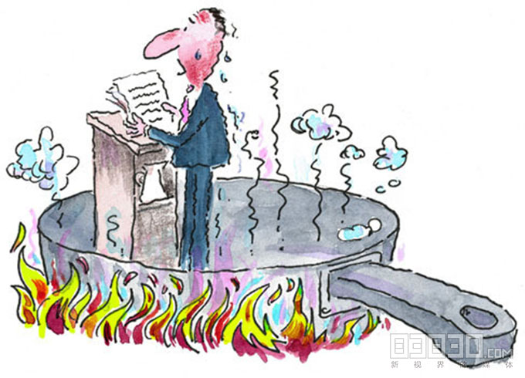

I am a very big perfectionist, but I also mess up under pressure. This leads to public speaking being quite the challenge for me, and I get incredibly anxious about it all. I try so hard to present myself and my words optimally, that it often falls apart when I commit. For example, in my summer semester, I had to do a “pitch” to policy makers regarding an article I read. A few seconds into it, I lost track of my planned remarks and started improvising.

In my experience, I really don’t do anything to mitigate this anxiety besides trying to ignore it, which never works. I feel as if where I can really improve is to take up the recommendation to make sure that my introduction is good, so that I feel more confident through the entirety of the presentation or speech. I also need to slow down, as when I get anxious, I speed up, which makes the issue worse.